Shrek and Donkey Clip
Supporting file: 02_SUPPORTING_FILES_BY_UNIT/09 - Video Clips/Shrek and Donkey Clip-a735b8dba7.mp4
Original package path: сontent/i7f142881-6adf-4c8e-83dd-151b73aca3ce/Content/videoplayback.mp4

Dramatic Irony - Scary Movie
Supporting file: 02_SUPPORTING_FILES_BY_UNIT/09 - Video Clips/Dramatic Irony - Scary Movie-c0b2ebb864.mp4
Original package path: сontent/i8521d09d-96fe-4fc5-bfa8-71a1666129d6/Content/videoplayback (1).mp4

Situational Irony - from "Glee"
Supporting file: 02_SUPPORTING_FILES_BY_UNIT/09 - Video Clips/Situational Irony - from Glee-d97f3930b1.mp4
Original package path: сontent/i8a189594-c569-419d-a59f-2c60be51805c/Content/videoplayback (2).mp4

1.2 Reading Strategies WS.docx
Supporting file: 02_SUPPORTING_FILES_BY_UNIT/09 - Video Clips/1.2 Reading Strategies WS.docx-b436504938.docx
Original package path: сontent/i8600d5a0-d671-434e-88ce-885f0930828a/Content/1.2 Reading Strategies WS.docx

Why Do People Write Short Stories?
Why do authors write? Perhaps writers want to make meaning of the world. Maybe they want to reflect on personal experiences and connect with readers. Sometimes, they might even hope to change the world. Identifying the purpose and intended audience for writing a text helps us to understand the text.
Many different types of characters and experiences may be found within the written page. We can become new people in our minds, identify with characters within the pages, or even take trips or vacations, and never leave our own reading spaces! Through all types of texts, we are able to remove ourselves from our own lives, and look into the lives of others.
The short story brings us little "slices of life," and can be just as memorable, effective, and amazing as any novel. In fact, many writers feel that the short story is a more difficult text to create, than a longer one, as the writing has to be concise and precise.

The Power of the Short Story
Below are quotes from three writers who each share their own views of the power of the short story.
"A short story is a different thing all together--a short story is like a kiss in the dark from a stranger.... " ~ Stephen King
"A short story is a shard, a sliver, a vignette. It's a biopsy on the human condition.... " ~ Will Self
"My short stories are like soft shadows I have set out in the world, faint footprints I have left. I remember exactly where I set down each and every one of them, and how I felt when I did. Short stories are like guideposts to my heart.... " ~ Haruki Murakam
Watch the following video about how to write a short story:
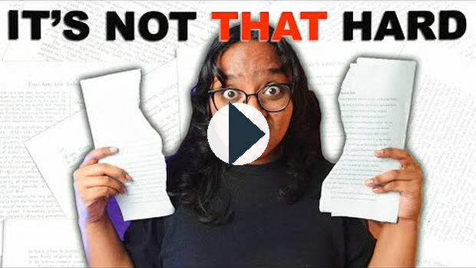
https://www.youtube.com/watch?v=5PCwca1a3uw
(this link opens in a new window/tab)

Developing a Plot
You have previously learned that the plot is one of the key elements of a short story. The plot is the backbone of your story. It’s the sequence of events that unfold, driving the narrative forward.
A strong plot will have a clear beginning, middle, and end. Focus on creating a narrative arc that builds tension and leads to a satisfying resolution. Think about what your characters want and what obstacles stand in their way. Use a plot diagram to visualize the rise and fall of action, ensuring your story has a satisfying arc.
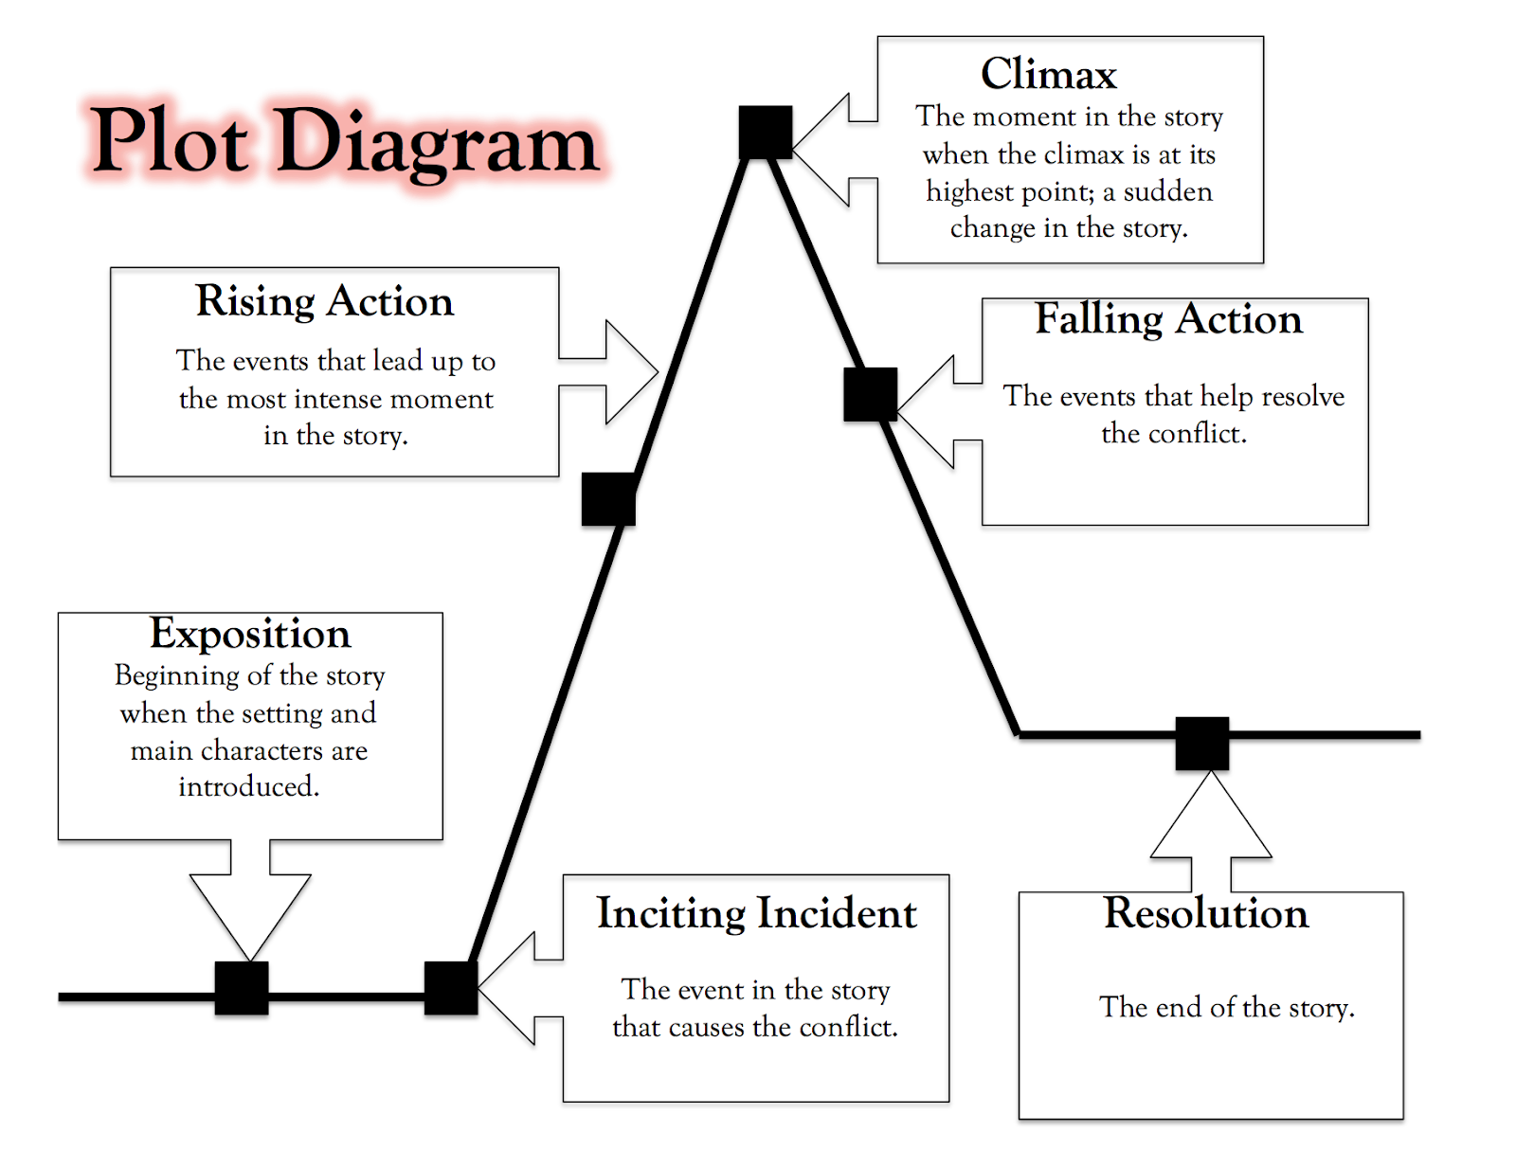

Things to Consider
When you are planning to write a short story, the following tips should assist you.

Character Crafting
Characters are the heart of your story. Develop your protagonist and other key players with detailed profiles. What are their desires, fears, and motivations? Crafting multidimensional characters will make your story more relatable and engaging.

World Building
Set the scene for your story. Whether it’s a bustling city, a quiet village, or an alien planet, your setting should be vivid and immersive. Use sensory details to transport your readers to the world you’ve created. The setting should complement and enhance the narrative.

Conflict Creation
Conflict is the engine of your story. It drives the plot and challenges your characters. Identify the central conflict early on and develop it throughout the story. This could be an internal struggle, a clash between characters, or an external obstacle.

Theme Weaving
Every great story has a deeper message. Determine the theme of your story—what do you want your readers to take away from it? Weave this theme subtly into your narrative, so it resonates without overshadowing the plot.

Point-of-View Selection
Choose the perspective from which to tell your story. First person, second person, or third person—each offers different advantages. The POV will shape how readers connect with your characters and perceive the events.

Dialogue Design
Dialogue breathes life into your characters. Craft conversations that sound natural and reveal character traits and plot points. Good dialogue moves the story forward and provides insight into your characters’ minds.

Descriptive Detailing
Use descriptive language to create vivid images in your readers’ minds. Focus on sensory details to make scenes come alive. Balanced description adds depth to your narrative without overwhelming the reader.

Scene Crafting
Identify and write the key scenes that form the backbone of your story. Each scene should have a purpose, whether it’s to advance the plot, develop characters, or highlight the theme. Ensure that every scene is engaging and drives the story forward.

The Grand Opening (Beginning Your Story)
Your story’s beginning sets the tone and hooks your readers. Start with a compelling scene or intriguing line that draws readers in. Establish your setting, characters, and conflict early to build interest.

The Big Finish (Ending Your Story)
A strong ending leaves a lasting impression. Wrap up your plot and resolve the central conflict. The ending should be satisfying and resonate with the theme of your story.
Information from: How to Write a Short Story (Ultimate Guide + Templates)
(this link opens in a new window/tab)

Making Your Writing Stronger
Once you have developed your plot, and have written a draft of your short story, it is time to look back and refine what you have written. The following suggestions should be considered as part of your proofreading and editing process.

Writing Powerful Leads
The opening few sentences of a piece of writing are most important. You must engage your reader's interest.
Here are some strategies you can use to give your stories a powerful beginning:
- open with dialogue between two characters that introduces the conflict
- begin with a description of the setting that creates a mood
- start in the middle of a dramatic action scene
- introduce the main problem in the story through the thoughts of a narrator
For example,
"I was getting fed up with saying goodbye. One month five kids disappeared from my shrinking class at Copelin High School."
- from "The Visitor" by Christine Pinsent-Johnson.
Christine Pinsent-Johnson begins her story by showing us how sad Willy feels about saying goodbye to his friends.

Making Your Characters Come Alive
Characters are the centre of any story. If you can create living, breathing characters, your audience will want to read about them.
To bring your characters to life, let your readers:
- see the way your characters look, move, and dress
- hear the thoughts and feelings of your characters
- hear your characters speak
- see the habits and personality traits of your characters
- feel your characters' problems

Using Colourful Language
Try to use interesting nouns, verbs, and modifiers so your readers will not become confused or bored.
- Nouns: Using specific rather than general nouns makes your message clear. See how the following sentence is improved by changing one noun.
I gasped when I turned the corner and saw the snake (general noun) in the middle of the room.
I gasped when I turned the corner and saw the python (specific noun) in the middle of the room.
- Verbs: If you want to ad some zip to your writing, look at the verbs you're using. Here are two sentences featuring the verb walk. See what happens to the sentences when the verb is changed.
Original Sentence | Revised Sentence
- Catriona pushed the rock aside and walked into the tomb.  - Kim Thanh walked to the stage to accept the trophy. | - Catriona pushed the rock aside and crept into the tomb.  - Kim Thanh leapt up to the stage to accept the trophy.
The new verbs create a mood in the sentences and give the reader a clearer picture of what is happening.
- Modifiers: Adjectives and adverbs are modifiers. They describe nouns and verbs, and some of the other parts of speech. You an use adjectives and adverbs to make your wriing more interesting. Modifiers also help to create a mood in your writing. See how these sentences come to life with interesting modifiers.
Original Sentence | Revised Sentence
- Emily skied down the mountain. (no modifiers)  - I stretched out on the grass and gazed into the sky. (no modifiers) | - Emily skied aggressively down the treacherous mountain. (modifiers add detail and excitement)  - I stretched out on the cool grass and gazed into the cloudless sky. (modifiers create a pleasant mood)

Writing Effective Dialogue
Read the dialogue that follows and think about what makes it work.
"'My dears, you're not going to believe what I saw last night,' she [Mrs. Tilley] said breathlessly. 'I was out for a walk and when I rounded the corner of Ore Street I stared straight into the glaring red eyes of the devil itself.'"
- from "The Visitor" by Christine Pinsent-Johnson
The author breathes life into the character of Mrs. Tilley with this speech. She reveals herself as excitable, talkative, and superstitious. The author also uses this speech to add humour to the story and to introduce sone important information about the visitor.
Here are some things to remember when you write dialogue:
- your dialogue should sound like real people speaking. You can use slang, incomplete sentences, dialect, and imperfect grammar. To check if your dialogue sounds like real speech, read it out loud.
- your dialogue should always serve a clear purpose: to show conflict or action, to reveal character traits, or to provide information.
- keep your speeches fairly short. The dialogue should move back and forth among characters.
- use dialogue to emphasize important scenes or turning points in your story.

How to Punctuate Dialogue
add in example from page 182

Writing Effective Endings
Have you ever been disappointed by the ending of a book, a story, or a movie? Good writing, in both fictions and non-fiction, leaves a reader with a sense of satisfaction ad completion. You may need to try several different endings to a piece of writing before you find one that feels right.
Here are three kinds of endings to try:
- Complete the circle - The story begins and ends with the narrator's thoughts about the main topic.
- End at a jumping-off point - You can leave your readers with something to think about, such as a question or an action yo think the reader should take. In a story, you can leave a character facing a choice or challenge. But if you do this, you must plant enough clues throughout the story to make the answer easy to predict or your reader will not be satisfied.
- Summarize your observations - You can sum up a lesson you learned for the ending to a personal narrative, or the lesson a character learned for the ending to a story.

When to Start a New Paragraph
Readers expect a long piece of writing to be divided into paragraphs. The beginning of a new paragraph tells the reader to expect a change of some kind.
Here are some of the changes that should signal when to start a new paragraph:
- A New Topic: Use a new paragraph when you move from one topic to another.
- A Change of Setting - Time or Place: Use a new paragraph to warn readers about a shift to a new time or place. This works best when the change is small - from morning to afternoon, or from inside to outside.
- To Give Emphasis: To emphasize an idea or action, you can put in a very short paragraph all by itself. This is a powerful technique, but don't use it too often or it will lose its power.
- A New Speaker: Start a new paragraph whenever someone begins to speak or when the speaker changes.

Editing and Proofreading Your Writing
Editing means making changes to your writing to improve it. Editing and rewriting are important parts of the writing process. Professional writers will tell you that writing is actually one-tenth writing and nine-tenths rewriting.
The hardest part of editing your own writing is trying to see it with fresh eyes. If possible, put it away for at least a day. When you read it again, pretend that it's someone else's work. Ask yourself "How can I make this better?"
Read your work several times and mark:
- places where your meaning is not clear
- word, sentences, or paragraphs that seem out of order
- words, sentences, or paragraphs to delete
- places where more information or explanation is needed
Proofreading your writing involves reading it over carefully to correct errors in punctuation, sentence structure, grammar, word choice, and spelling.

Proofreading Checklist
√ Did I check the spelling of any words I was unsure about? | √ Did I use a variety of sentence lengths?
√ Did I choose words that express my thoughts clearly? | √ Did I use quotation marks for dialogue and quotations?
√ Did each of my sentences end with a punctuation mark? | √ Did I either leave a blank line before each paragraph or indent each paragraph?
√ Are all of my sentences complete? | √ Did I capitalize the first word in each sentence, and all proper nouns and titles?
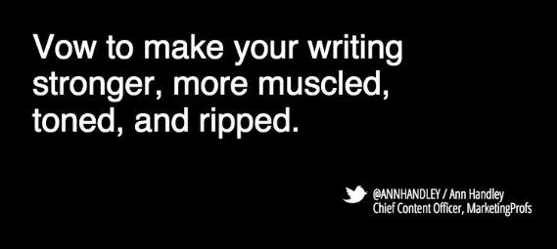
(this link opens in a new window/tab)

